ISOLATING SPARK GAP – SURGE ARRESTER

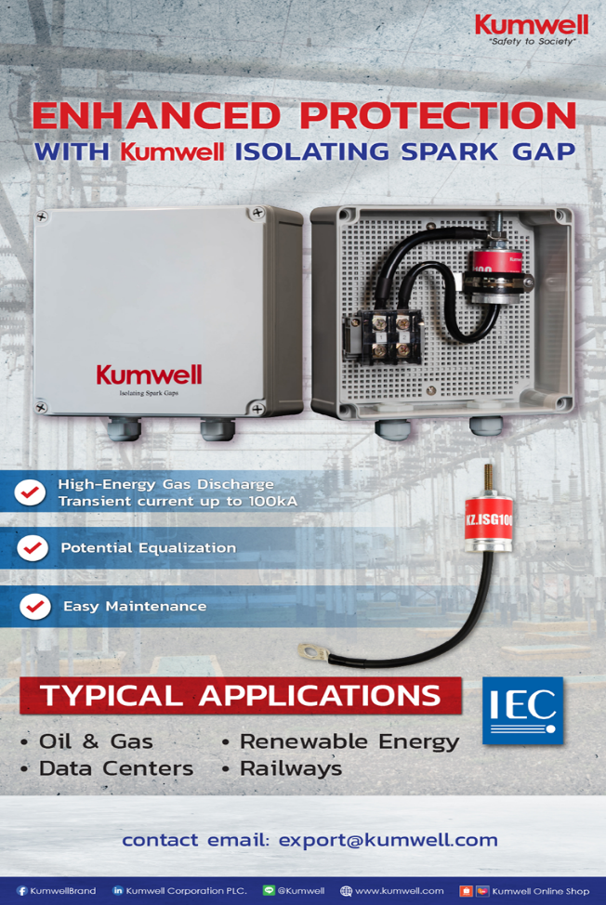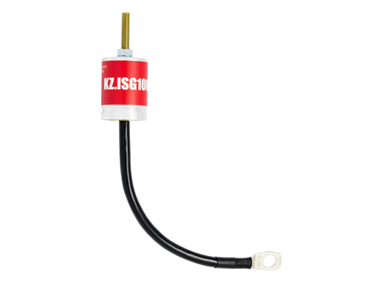

KUMWELL Isolating Spark Gap (ISG) is a high-power Gas Discharge Tube (GDT) designed to provide equipotential bonding between separate grounding systems while maintaining electrical isolation under normal operating conditions.

During lightning strikes or transient overvoltage events, the ISG automatically activates when the voltage difference between the two grounding points exceeds its sparkover threshold, safely equalizing potentials and diverting surge currents. This helps protect equipment, prevent dangerous potential differences, and enhance overall system safety and performance.

Designed and tested in accordance with IEC 62561-3, Kumwell ISGs are ideal for lightning protection, grounding, telecommunications, industrial facilities, power systems, and other critical infrastructure applications. For optimum performance and service life, installation is recommended in indoor or underground environments.

